**­Quiz 5**

**DSCI 558 BUILDING KNOWLEDGE GRAPH**

Name: ________________________________________________

­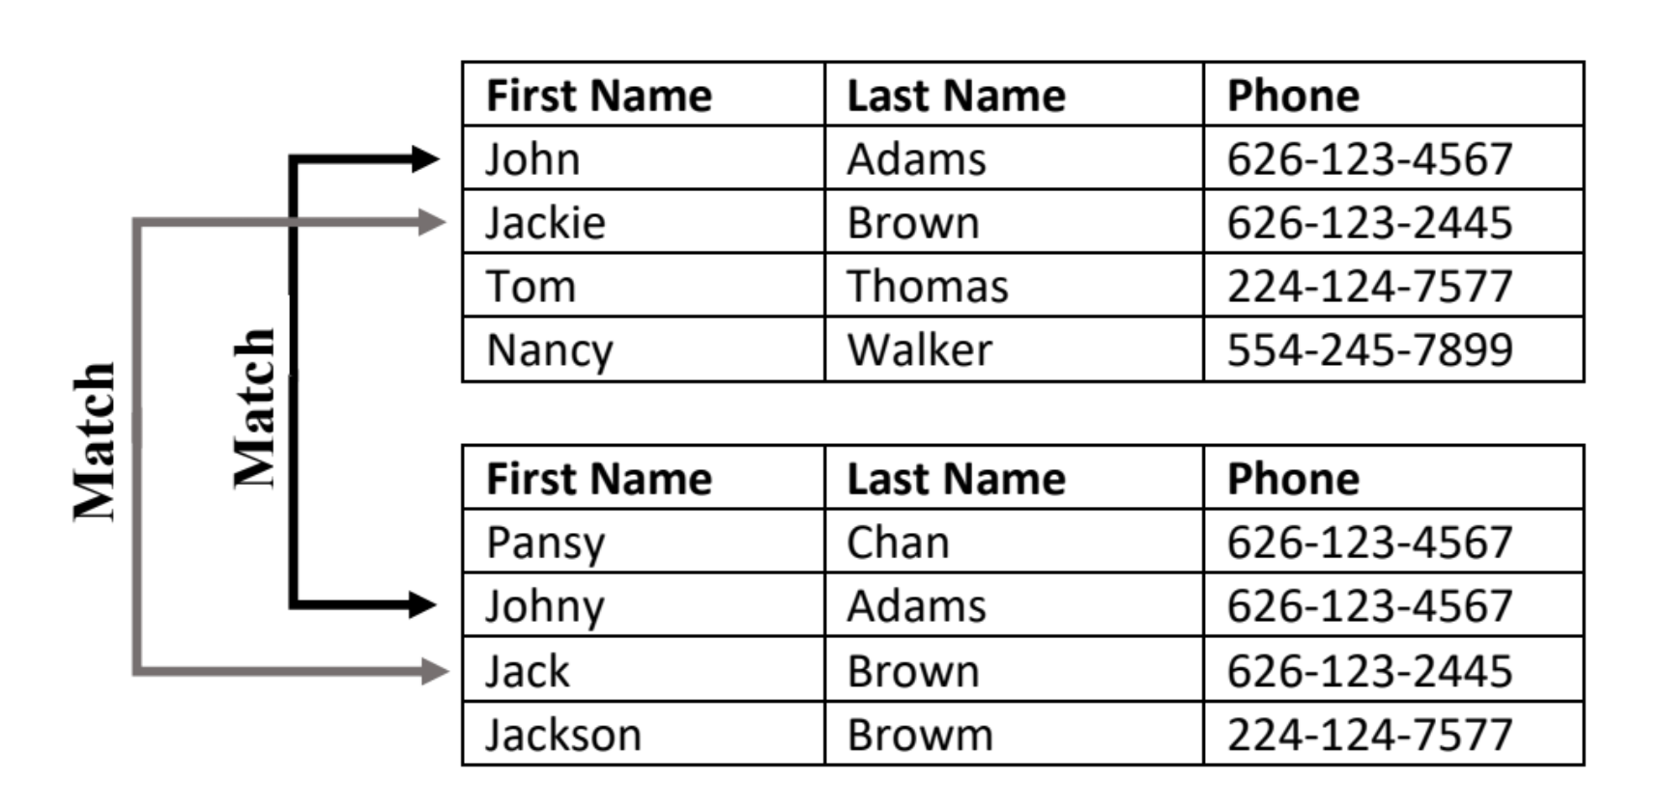­­­­

**Question 1 (5 points):**

Given the two above tables, how many record comparisons a record linkage method need to make without any blocking? 16

If we use the blocking rule **(1st letter of Last Name),** how many comparisonsneed to be made? 3

**Question 2 (5 points):**

 Map the type of task that should be performed for each of the following scenarios:

|  |  |  |  |
| --- | --- | --- | --- |
| 1. | IMDB wants to link their database to Wikidata. |  | Entity Linking/Record Linkage |
|  |  |  |  |
| 2. | USC CS department opened a Google Form for students to register for D-clearance (one for each course). After one week, the department wants to generate a report on how many D-clearances each student has requested. |  | Deduplication |
|  |  |  |  |
| 3. | Amazon decided to buy Fandango and is interested in enriching Fandango website using IMDB reviews. |  | Entity Linking/Record Linkage |